1. Which are the top three variables in your model which contribute most towards the probability of a lead getting converted?

Answer: According to the graph below Lead Origin_Lead Add Form, Occupation_Working Professional, Lead_Source_Welingak website contribute most towards the probability of a lead getting converted.

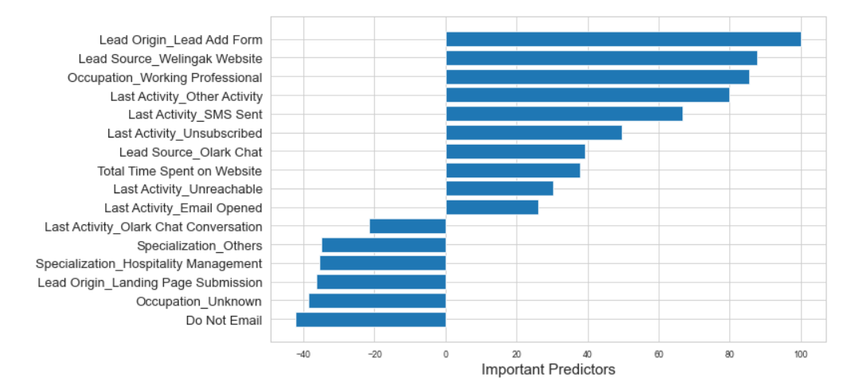

1. What are the top 3 categorical/dummy variables in the model which should be focused the most on in order to increase the probability of lead conversion?

Answer: Focus on Lead Origin_Lead Add Form, Occupation_Working Professional, Lead_Source_Welingak website is must to increase the probability of lead conversion

1. X Education has a period of 2 months every year during which they hire some interns. The sales team, in particular, has around 10 interns allotted to them. So during this phase, they wish to make the lead conversion more aggressive. So they want almost all of the potential leads (i.e. the customers who have been predicted as 1 by the model) to be converted and hence, want to make phone calls to as much of such people as possible. Suggest a good strategy they should employ at this stage.

Answer: Since there are more number of resources, the company can contact people with probability of conversion around 0.1 as well.

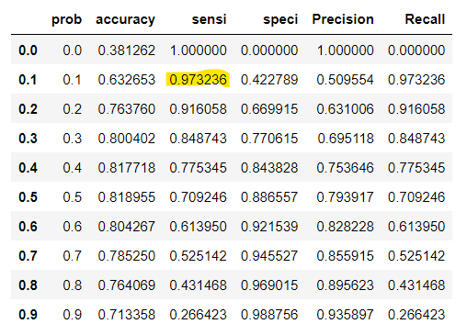

1. Similarly, at times, the company reaches its target for a quarter before the deadline. During this time, the company wants the sales team to focus on some new work as well. So during this time, the company’s aim is to not make phone calls unless it’s extremely necessary, i.e. they want to minimize the rate of useless phone calls. Suggest a strategy they should employ at this stage.

Answer: If there are limited sales representatives, then score cut-off should be higher to ensure a higher conversion probability people are contacted further to turn them into a potential customer. It is the same as increasing the precision value of the model by adjusting the cut-off point to a higher value. Here the model can wrongly predict the lead that might have converted as not converted. They can also use methods such as SMS, automated emails to avoid calls.